|  |  |
| --- | --- |
| . |  |



CSE 5280

Computer Graphics

Spring 2016

|  |
| --- |
| **Class Assignment-03**  **( Space Carving Animation )** |

Student Name: _____**Jay Sandeepkumar Modi**____

Student ID: **____________902292667______________**

|  |  |
| --- | --- |
|  | **Professor:** [Dr. Eraldo Ribeiro](https://fit.instructure.com/courses/452648/users/753896)  [eribeiro@cs.fit.edu](mailto:mcarvalho@fit.edu) |
|  |  |

**Space Carving Animation:**

**Code:**

% Demonstrates the projection of a set of 3-D points onto an image. The

% projection matrix was obtained from camera calibration.

tic;

% clean up memory and close all figures

close all;

clear all;

% Pose number

imNumber = '0112';

run=0;

if (run == 1 )

minX = -0.3;

minY = 0.1;

minZ = -0.3;

maxX = 0.2;

maxY = 1.7;

maxZ = 0.2;

step = 0.03;

else

minX = -2.0;

minY = -2.0;

minZ = -2.0;

maxX = 2.0;

maxY = 2.0;

maxZ = 2.0;

step = 0.1;

end

% These are the first frames on Cameras 1 and 2

Cam(1).im = rgb2gray(imread(strcat('silhouettes/Silhouette1_',imNumber,'.png')));

Cam(2).im = rgb2gray(imread(strcat('silhouettes/Silhouette2_',imNumber,'.png')));

Cam(3).im = rgb2gray(imread(strcat('silhouettes/Silhouette3_',imNumber,'.png')));

Cam(4).im = rgb2gray(imread(strcat('silhouettes/Silhouette4_',imNumber,'.png')));

Cam(5).im = rgb2gray(imread(strcat('silhouettes/Silhouette5_',imNumber,'.png')));

Cam(6).im = rgb2gray(imread(strcat('silhouettes/Silhouette6_',imNumber,'.png')));

Cam(7).im = rgb2gray(imread(strcat('silhouettes/Silhouette7_',imNumber,'.png')));

Cam(8).im = rgb2gray(imread(strcat('silhouettes/Silhouette8_',imNumber,'.png')));

object_point=[];

% Number of Cameras

noc = 8;

% Sample 3-D points within a cube shape centered at the origin

for X = minX : step : maxX

for Y = minY : step : maxY

for Z = minZ : step : maxZ

hit=0;

% Display the projection of cube points as seen from Cameras 1 to 8

for iCam = 1 : noc

% Obtain projection matrix for camera iCam

P = getProjMatrix( iCam );

% Project 3-D points to image points

x = P * [ X Y Z 1 ]';

% Transform homogeneous coords into cartesian

u = x(1)/x(3);

v = x(2)/x(3);

if ( v <= size(Cam(iCam).im,1) && u <= size(Cam(iCam).im,2) && 1 <= u && 1 <= v)

if( (Cam(iCam).im(round(v),round(u))) ~= 0 )

hit = hit + 1;

end

end

end

% Storing points if a point is hit by all the cameras.

if(hit == noc)

temp = [ X Y Z ]';

object_point = [object_point, temp ];

end

end

end

end

%display(object_point);

minX = min(object_point(1,:));

minY = min(object_point(2,:));

minZ = min(object_point(3,:));

maxX = max(object_point(1,:));

maxY = max(object_point(2,:));

maxZ = max(object_point(3,:));

object_point=object_point';

function P = getProjMatrix(i)

% Projection matrix for Camera i

%

% Projection matrices are hardcoded for simplicity. But, we could just read

% them directly from the calibration files.

Calib(1).P = [ 1.483215e+03 -7.953666e+02 -9.153119e+02 4.046004e+03; ...

-5.395400e+01 -1.719494e+03 3.606972e+02 3.961539e+03; ...

-6.991278e-02 -9.069575e-01 -1.063456e+00 4.753082e+00 ];

Calib(2).P = [ 1.677218e+03 -7.084734e+02 5.732087e+02 5.171564e+03; ...

-1.814967e+02 -1.743858e+03 3.993065e+00 4.314523e+03; ...

8.810557e-01 -7.603295e-01 -7.786652e-01 6.074740e+00 ];

Calib(3).P = [ 9.269854e+02 -7.025415e+02 1.509225e+03 4.448627e+03; ...

-1.922770e+02 -1.737088e+03 -7.511179e+01 4.261084e+03;...

1.152985e+00 -7.936465e-01 -3.782901e-02 5.152725e+00 ];

Calib(4).P = [ -3.529096e+02 -6.068026e+02 1.769746e+03 4.453332e+03; ...

-5.880053e+01 -1.765468e+03 -8.726954e+01 4.527056e+03;...

8.825374e-01 -7.435539e-01 7.937028e-01 6.003132e+00 ];

Calib(5).P = [ -1.532662e+03 -7.698217e+02 8.246429e+02 3.787523e+03; ...

2.544591e+01 -1.720718e+03 -4.054952e+02 3.874761e+03;...

1.776188e-02 -9.415247e-01 1.036173e+00 4.695420e+00 ];

Calib(6).P = [ -1.732989e+03 -5.827524e+02 -6.096631e+02 4.869964e+03;...

8.629205e+01 -1.771143e+03 -1.076821e+02 4.426927e+03;...

-9.177131e-01 -7.547954e-01 7.410083e-01 6.032102e+00 ];

Calib(7).P = [ -8.914168e+02 -6.960165e+02 -1.548135e+03 4.017688e+03;...

2.466475e+02 -1.750562e+03 2.269384e+01 4.171231e+03; ...

-1.119922e+00 -8.401569e-01 2.586530e-04 5.181506e+00 ];

Calib(8).P = [ 4.011197e+02 -5.661652e+02 -1.788971e+03 4.441950e+03;...

1.039635e+02 -1.761553e+03 4.867437e+01 4.503671e+03; ...

-8.417806e-01 -7.415664e-01 -8.374394e-01 6.065466e+00 ];

P = Calib( i ).P;

return

**Steps followed:**

1. Take any pose number (imNumber) and run = 0 (Range = -2 to 2 and steps = 0.1), then execute the above program.
2. Now, get the value of minX, minY, minZ, maxX, maxY, and maxZ.
3. Now, update run = 1 (Range changes according to the min-max value of X, Y, and Z, and step = 0.03), and run the program again.
4. Save the object points in .txt file from the workspace.
5. Now, import this .txt file in MeshLab tool.
6. Following the procedure to create mesh from the object points.
7. Repeat steps 1-6 for all poses.
8. Save output by taking snapshot, and create animation.

**Result:**

**Object points:**

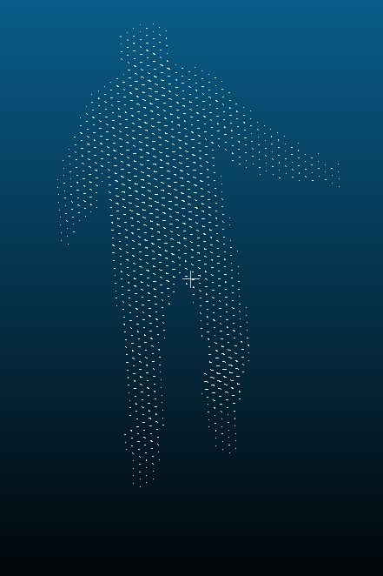

**Mesh:**

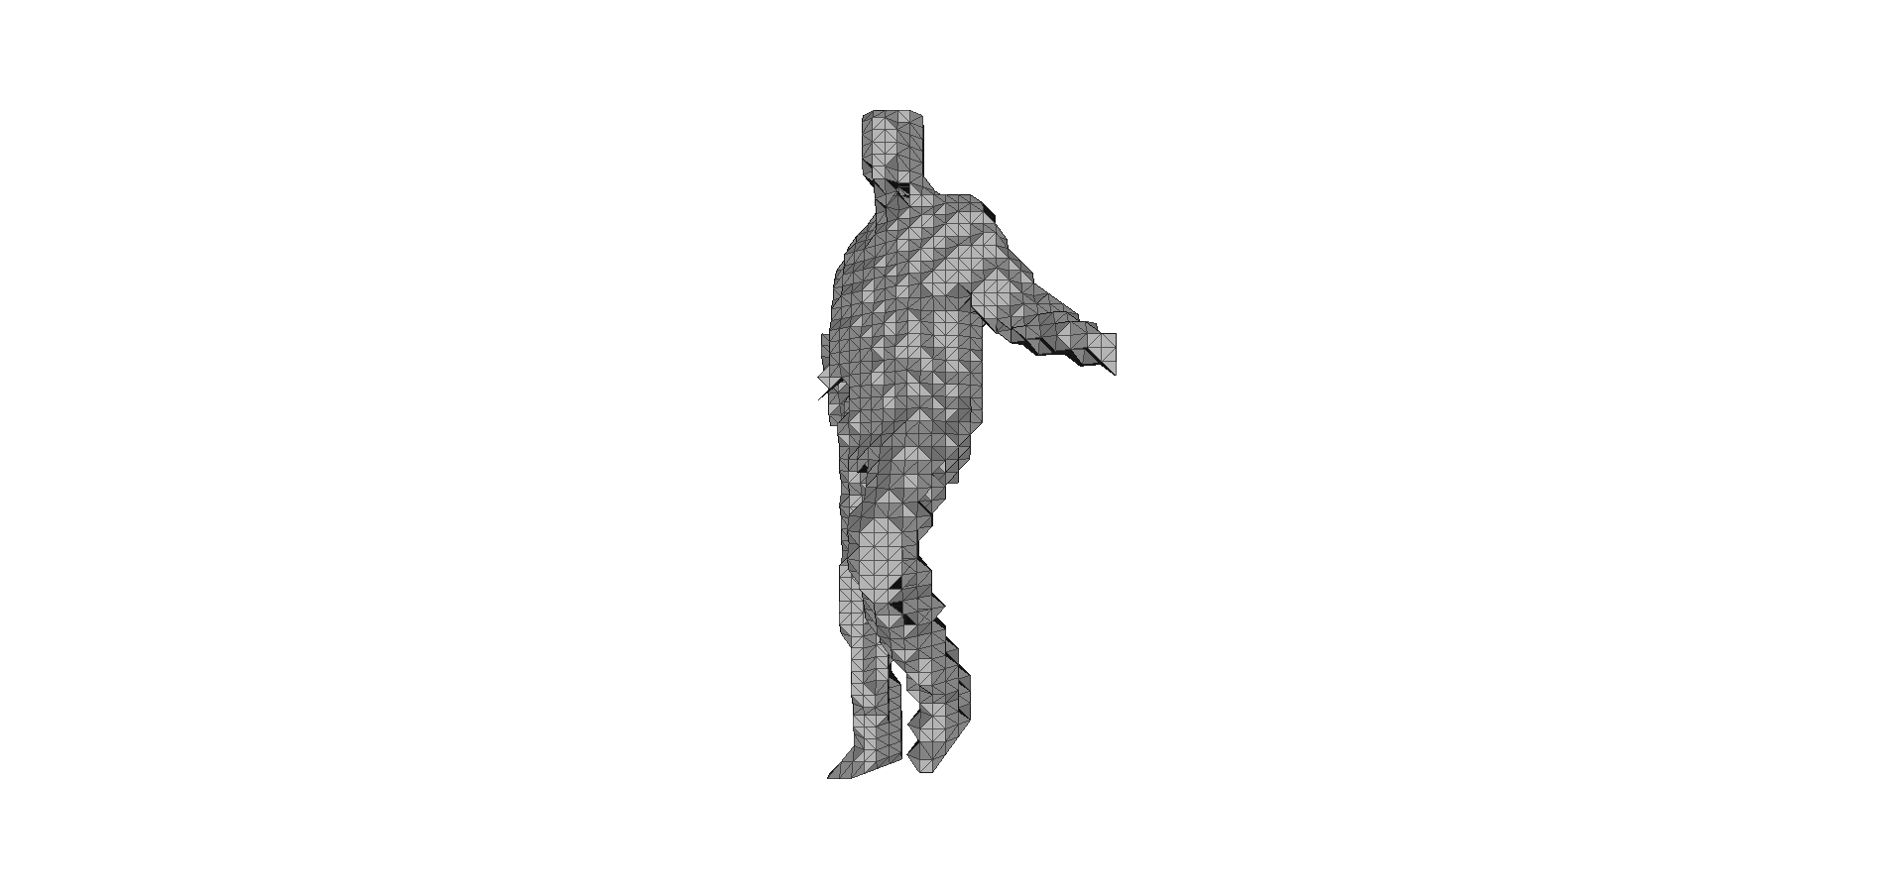

**Note:** Output animation is stored in output.gif, which can be found in zip file.